**New Form Elements**

**HTML5 added the following form elements:**

* <datalist>
* <output>

## **HTML5 <datalist> Element**

The <datalist> element specifies a list of pre-defined options for an <input> element.

Users will see a drop-down list of the pre-defined options as they input data.

The list attribute of the <input> element, must refer to the id attribute of the <datalist> element.

**Example:**

**<form action="/action_page.php">**

**<input list="browsers">**

**<datalist id="browsers">**

**<option value="Internet Explorer">**

**<option value="Firefox">**

**<option value="Chrome">**

**<option value="Opera">**

**<option value="Safari">**

**</datalist>**

**</form>**

**Output:**

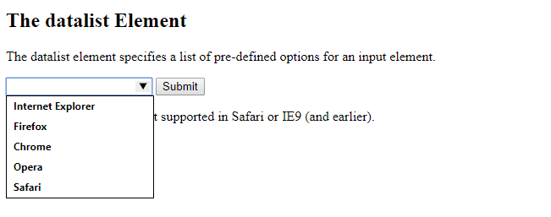

***Note:*** *The datalist tag is not supported in Safari or IE9 (and earlier).*

**2. Meter and Progress Tag**

**2.1 Meter Tag**

The <meter> tag defines a scalar measurement within a known range, or a fractional value. This is also known as a gauge.

Examples: Disk usage, the relevance of a query result, etc.

Note: The <meter> tag should not be used to indicate progress (as in a progress bar). For progress bars, use the [<progress>](https://www.w3schools.com/tags/tag_progress.asp) tag.

**Example:**

**<meter value="2" min="0" max="10">2 out of 10</meter><br>**

**<meter value="0.6">60%</meter>**

**Output**

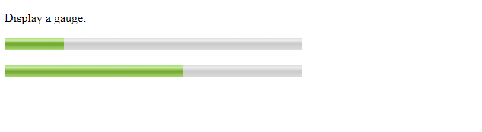

***Note:*** *The <meter> tag is not supported in Internet Explorer, Edge 12, Safari 5 and earlier versions.*

**2.2 Progress Tag**

The <progress> tag represents the progress of a task.

Something like Downloading and file copying progress bars

**Example:**

**<progress value="22" max="100"></progress>**

**Looks Like:**

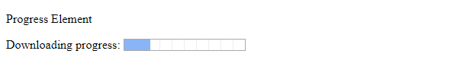

***Note 1:*** *The progress tag is not supported in Internet Explorer 9 and earlier versions.*

***Note 2:*** *Use the <progress> tag in conjunction with JavaScript to display the progress of a task.*

***Note 3****: The <progress> tag is not suitable for representing a gauge (e.g. disk space usage or relevance of a query result). To represent a gauge, use the* [*<meter>*](https://www.w3schools.com/tags/tag_meter.asp) *tag instead.*

## 

## 

## 

## 

## 

## ***3. New Semantic/Structural Elements***

*HTML5 offers new elements for better document structure:*

|  |  |
| --- | --- |
| **Tag** | **Description** |
| [<article>](https://www.w3schools.com/tags/tag_article.asp) | Defines an article in a document |
| [<aside>](https://www.w3schools.com/tags/tag_aside.asp) | Defines content aside from the page content |
| [<bdi>](https://www.w3schools.com/tags/tag_bdi.asp) | Isolates a part of text that might be formatted in a different direction from other text outside it |
| [<details>](https://www.w3schools.com/tags/tag_details.asp) | Defines additional details that the user can view or hide |
| [<dialog>](https://www.w3schools.com/tags/tag_dialog.asp) | Defines a dialog box or window |
| [<figcaption>](https://www.w3schools.com/tags/tag_figcaption.asp) | Defines a caption for a <figure> element |
| [<figure>](https://www.w3schools.com/tags/tag_figure.asp) | Defines self-contained content |
| [<footer>](https://www.w3schools.com/tags/tag_footer.asp) | Defines a footer for a document or section |
| [<header>](https://www.w3schools.com/tags/tag_header.asp) | Defines a header for a document or section |
| [<main>](https://www.w3schools.com/tags/tag_main.asp) | Defines the main content of a document |
| [<mark>](https://www.w3schools.com/tags/tag_mark.asp) | Defines marked/highlighted text |
| [<meter>](https://www.w3schools.com/tags/tag_meter.asp) | Defines a scalar measurement within a known range (a gauge) |
| [<nav>](https://www.w3schools.com/tags/tag_nav.asp) | Defines navigation links |
| [<progress>](https://www.w3schools.com/tags/tag_progress.asp) | Represents the progress of a task |
| [<rp>](https://www.w3schools.com/tags/tag_rp.asp) | Defines what to show in browsers that do not support ruby annotations |
| [<rt>](https://www.w3schools.com/tags/tag_rt.asp) | Defines an explanation/pronunciation of characters (for East Asian typography) |
| [<ruby>](https://www.w3schools.com/tags/tag_ruby.asp) | Defines a ruby annotation (for East Asian typography) |
| [<section>](https://www.w3schools.com/tags/tag_section.asp) | Defines a section in a document |
| [<summary>](https://www.w3schools.com/tags/tag_summary.asp) | Defines a visible heading for a <details> element |
| [<time>](https://www.w3schools.com/tags/tag_time.asp) | Defines a date/time |
| [<wbr>](https://www.w3schools.com/tags/tag_wbr.asp) | Defines a possible line-break |

**References**

1. **https://www.w3schools.com/tags/tag_meter.asp**
2. **https://www.w3schools.com/html/html5_new_elements.asp**
3. **https://www.w3schools.com/tags/tag_datalist.asp**
4. **https://www.w3schools.com/tags/tag_progress.asp**